The Nature of Sagittarius A*

Lindsay Oaster
11/12/03
AST 307

Black holes are one of the more exotic things to explore in our universe. They are introduced to high school physics students to spark their interest in studying astronomy, given descriptions like “tears in the very fabric of space-time,” and tend to be good crowd-pleasing subject matter. Even those who are novices to the field of astronomy can understand the idea behind them. More interestingly, it is said that a giant black hole resides in the very center of our Milky Way. But since the whole point of the “black hole” name indicates that light can’t escape, how are they seen? Ergo, how would we be able to confidently say that our galaxy’s center really is a black hole, and not something less exotic, like a mass of stars that’s simply more dense than those in our neighborhood? The following sources have attempted to answer these questions, with some interesting results.

Detecting the Black Hole
Even though a characteristic property of black holes is that they can’t be seen, their effects on nearby objects can give evidence of their presence. One such effect is this: as a black hole pulls in gas from nearby stars, the gas forms an accretion disk. It swirls around faster and faster, colliding with other gas molecules and heating up. When the gas has a certain energy, it emits X-rays that we can observe (NASA 2002). In fact, black holes have been termed “sloppy eaters” because of the effect seen when a black hole draws in too much gas. The force of gravity swirls the excess gas around at incredibly high speeds, and it is ejected into space from both poles of the black hole. Additionally, a group of researchers found a way to detect a “shadow” that the black hole leaves in space (Falcke et al 1999). They observed radio waves that were nearly pulled into the event horizon, and depending on how they approached it, those radio waves could either be significantly reduced or amplified. Radiation that skims the black hole at a shallow angle is amplified in much the same way that the “slingshot effect” works for accelerating spacecraft around planets. However, radio waves that approach the mass at a steeper angle are bent much more, and they lose energy in their struggle to escape gravity’s pull. Looking at the black hole, these lower-energy waves would appear to come from the center. Therefore, the plot of radiation intensity would show a peak on either side of the black hole, and a significant dip in between the peaks. Figure 1 illustrates this nicely:

Fig. 1: Radiation Intensity (Falcke et al 1999)
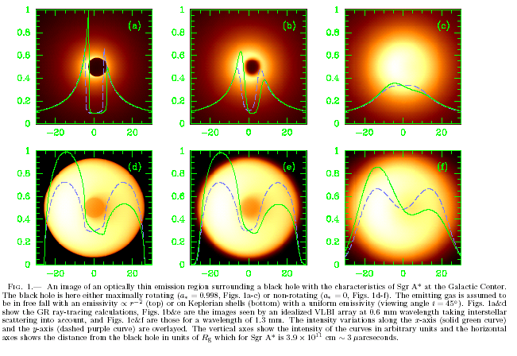

Looking Inward
In the 1970’s, a large radio source was discovered at the center of our galaxy. Sagittarius A* seemed to be emitting radio waves and sometimes X-rays, but nothing in the visible spectrum. To investigate what SgrA* was, astronomers studied the motions of other stars in the nearby area in order to determine their masses, and then plotted the enclosed mass versus the distance from SgrA*. Figure 2 shows this plot:

Fig. 2: Enclosed Mass (Genzel et al 2002)
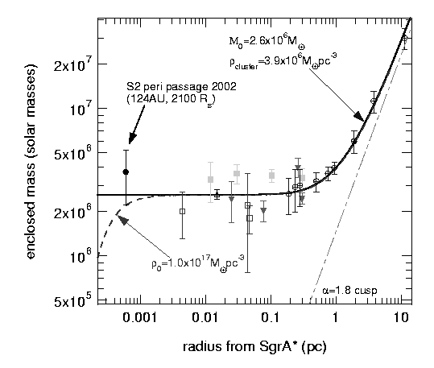
Their models (the dashed lines) predicted that the mass would begin at a low value and increase as one moved further away. What they found was that the enclosed mass is initially quite high, and it stays fairly constant until about 0.1 parsecs, where the enclosed mass then increases. This indicates that SgrA* is so incredibly massive that it alone skews the data curve. And indeed, they calculated its mass to be 3x10⁶ M. They also discovered that it’s spinning quite rapidly; by observing a gas pocket that was very near the event horizon, they found its period to be only 17 minutes (Schödel et al 2002). So there is a lot of energy associated with this mass to be able to rotate so quickly.
Additionally, astronomers at the Max Planck Institute were studying the kinematics of nearby stars; the data would be helpful for another purpose besides mass determination. They were able to measure enough of the orbit of one star, S2, to confidently project what its entire orbit is about the galactic center (SgrA*). This was a substantial find; it takes about 240 million years for our Sun to orbit about the galactic center, and yet here was a complete stellar orbit, measured in a decade. And what’s more, S2’s orbit nicely matches a predicted model for a star orbiting a single, highly massive object (Genzel et al 2002). This new data gave the most convincing evidence that SgrA* is in fact a black hole, and not a cluster of dark stars.
Figure 3 shows S2’s complete orbit, with the last quarter of the orbit extrapolated from the data.

Fig. 3: The Orbit of S2 (Genzel et al 2002) 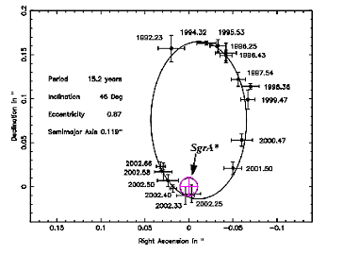
What Else Can it Be?
There were several other theories as to the nature of SgrA* at the time. Most of them involved a cluster of things as opposed to a single object. One stated that a cluster of neutron stars would have similar effects on their neighbors (the accretion disk and resulting X-ray emission, for example). Another said that it was a cluster of smaller black holes as opposed to one large one. And a third stated that SgrA* is a large mass of heavy neutrinos. However, according to Schödel in his paper, after applying the appropriate Plummer distribution to each of the three models, they would all collapse to a single black hole after only 100,000 years. This is much too short a time to be feasible, so those three theories are safely eliminated.
There were two other theories that were a little more persistent. One stated that SgrA* was a large general fermion mass held against gravitational collapse by degeneracy pressure (Schödel et al 2002). This star would not collapse into a black hole, and thus couldn’t be eliminated by the previous method. However, S2’s orbital period gave researches the tool they needed. Predicting what S2’s orbit would be around this fermion mass, they found that it would have an orbital period of at least 32 years. S2’s actual period is only 15 years. This was what enabled them to disregard that model. However, there is still a second model that they haven’t been able to eliminate. It predicts that a boson star lies at the center of the galaxy. Such a star is only theoretical, but it is a reasonable idea. For one thing, its size is only a little larger than the Schwarzschild radius of a black hole with the same mass. It also has relativistic properties (concerning the effects observed of an object approaching the boson star), unlike the fermion mass model (Torres). But one question persists: How could the bosons reach such a high density as this without collapsing into a black hole by baryonic accretion? Unless this is answered, the black hole model continues to be the more probable case.

Looking Forward
The researchers at the Max Planck Institute are continuing to research the galactic center. The SHARP I camera is what enabled them to resolve the stars near SgrA*, and they are continuing to improve the optics to achieve better resolution. They are also observing stellar motions around the mass. S2’s orbit revealed much information and was able to eliminate several “competing” theories, so obtaining the orbits of several more stars can only add to their confidence level. Additionally, they are observing relativistic motions in the vicinity of the black hole (10-100 Schwarzschild radii), possibly to compare with predictions against the theoretical relativistic properties of a boson star.
Research papers on the subject of Sagittarius A* abound, and there is still more to discover as the technology improves.

