Ion Milling Instructions – J. Glick (2016), updated N. Satchell (2017)
Loading the Sample Holders
- Using a sharpie, write the sample number the Copper/Brass heat sink and magnetic disk.
- Make certain to either use a sample mask or apply silver paste/vacuum grease to the back of the sample. This will ensure good thermal conduction to the heat sink.
- Use only sample holders with countersunk screw holes. If you don’t know what a countersink is, ask. Using a non-countersunk screw hole will cause your sample to not sit properly in the system.
- Do not over-tighten the screws until you’re certain the holder will lie flush to the sample. Some holders (when using a mask) are deep enough to potentially crack the sample if you’re not careful. Also, if the sample holder is tilted with respect to the heat sink, you will have trouble loading, or the sample will not face the ion mill properly.
Default Ion Mill Chamber Condition
- Turbo pump on, turbo backing pump on, roughing pump off.
- Chamber open to turbo pump via gate valve.
- Black Ar valve closed.
- Chamber open to load lock.
- Load lock closed to roughing pump (gold valve) and N2 vent gas (green valve). Do not leave gold valve open to the roughing pump over night as pump oil will creep up the hose line.
Loading the Ion Mill Chamber
- Double check that the black gate valve, found just below the load lock door, is closed tightly. Do not assume that it has been closed. Sometimes this is left open to pump out the load lock for faster loading. Also, turn off the Ion Gauge (if it is on).
- Vent the load lock by opening the green valve and releasing some nitrogen gas into the system. You do not need to open the valve very far. Leave the gas running while you put your sample in.
- Place your sample in the sample loading stick with the magnet facing up.
- Open the door and insert the sample into the load lock. You may need to bring the magnetic arm down slightly so that you can see the end. Attach the sample to the end of the magnetic arm and close the door. Close the nitrogen gas (green) valve.
- While holding the door closed, open the gold valve approximately halfway (roughly 1” of screw visible).
- Wait until the 10^-2’s, close the gold valve and flush with the dry N2. Reopen the gold valve. This helps remove water vapor. Depending on humidity repeat 2x or 3x.
- Wait until the pressure is at least 1*10^-2 torr on the pressure gauge. Generally, it is best to wait until several times 10^-3 since the pressure will come up when you close the valve.
- Close the gold valve first. Then open the gate valve.
- Carefully lower the sample into the chamber. Insert the sample into a sample slot and rotate the plate to drag the sample off the end of the magnetic probe. You may need to rotate the magnetic probe to get better alignment, or slightly misalign the sample on the end of the probe to get the sample into the slot.
- Remove the magnetic arm and close the gate valve.
- Rinse, wash, and repeat for all your samples (up to 5 maximum).

Ion Milling
- Check the Ion Gauge. The pressure should be below 1*10^-7 (preferably 2*10^-8 if possible). This may take pumping down overnight to achieve.
- Plug in the Ion Mill power supply if it isn’t already. You need to connect the power feed to the power strip, and connect the white Teflon connector to the similar connector underneath the chamber. Make sure the two lines line up on both the top and bottom of the plug.
- Power on the Ion Mill power supply and leave for at least 15 minutes to warm up prior to use.
- Make sure the shutter plate is closed to AU. Use the “right window” (facing the sputtering chamber) and look for the line on the shutter plate that is labelled “Au”. Rotate the plate 90 degrees away from that line (it will either read “SiOx” or “IM”).
- Make sure the water is running. Turn on the additional cooling fan by the chamber.
- Turn on the argon by opening the black valve underneath the Ion Mill Chamber. The flow meter should rise to read roughly 0.7 (it may fluctuate slightly, but not much).
- Close the gate valve separating the turbo pump from the main chamber. Find the point when the pressure reads:
  - ~7x10^-4 for Au sputtering
  - ~1.9x10^-4 for ion milling
- Rotate the Sample Plate so that the Film Thickness Monitor (FTM) is over the gold. Set the program to Au (program 2). Use the “front window” (facing the hallway) and find when the FTM is in front of the Ion gauge, or directly behind the centre post holding up the sample holder.
- Turn on the Au gun. If it doesn’t come on, try closing the gate valve until it does come on, and then open it again to ~7x10^-4. Make sure the gun doesn’t shut off again.
- Rotate the shutter plate to the “Au” position. Line up the drawn line on the shutter plate with the line drawn on the bottom of the right window. Watch the FTM and deposit about 450-500 Angstroms of gold per sample.
- Once the thickness is correct, close the shutter plate and turn off the Au gun.
- Move the FTM over the IM. Use the right window and look for a scratch on the side of the sample holder plate. When the FTM is in front of the gate valve, and the sample plate scratch lines up with the line in the window, you’re set.
- Open the gate valve until pressure reduces to ~1.9x10^-4.
- Make certain the shutter plate is closed to the IM. Setting it in the “Au” position is good here.
- If power supply knobs are already set to approximately the correct values proceed as below. Otherwise see “Troubleshooting: Setting up power supply from scratch.”
- Power on the Ion Mill by flipping the two switches one at a time to engage the supply. Check there are no blinking lights. Set the values as below (press black switch below each control knob to view). These values may change during the run. You should get a feel for how the milling rate changes depending on how the values change as you use the system.
Variable | Left Display (BEAM) | Right Display (MONITOR)
No switch pressed | Beam current (mA)  9.0 (controlled with cathode) | Accelerator current (mA)  0
Discharge |  | Discharge voltage (V)  39
Cathode |  | Cathode current (A)  3.6 – 4.2 (new filaments up to 5.5)
Beam Voltage | Beam voltage (V)  300
Accelerator |  | Accelerator voltage (V)  30
Neutraliser |  | Neutraliser current (mA)  9.5 (0.5 higher than beam current)

- Expose the FTM to the Ion Mill by aligning the “IM” line on the shutter plate with the line in the right window. Watch the rate on the FTM until it stabilizes. Record that rate.
- Close the shutter plate. Move the first sample over the Ion Mill. Open the shutter plate to the “IM” Line. Immediately start the timer.
- Calculate the milling time based on the rate of gold milling, and the relative thickness of gold you wish to mill. Ask how to perform that calculation (or look for similar calculations in the book) prior to running the system.
- When the time is up, close the shutter plate. Move the FTM back over the IM. Open the shutter plate again and double check the rate. If the rate has dropped too much, quickly calculate the new length of milling time with the new rate, take the difference in the original time and the new time and divide by two. Mill the sample for that new time. That gives a rough correction for the decay in the milling rate.
- Rinse, wash, and repeat on all of your samples.

Shutting Down
- Turn off the two power switches on the Ion Mill power supply. Leave the supply itself on for a few minutes to cool.
- Open the gate valve all the way.
- Turn off the Argon.
- Turn off the IM power supply and unplug it. Return it to its place under the Sputtering System setup table unless you plan on using the power supply again soon.

SiOX Deposition
- Flip the red switch on (it’s hiding on the metal framework, above the Ar flow monitor), and turn on the volt meter (if it is off).
- Set the shutter plate in either the “NO” or “Au” positions. Place the FTM roughly over the SiOx source – it should be a little to the left when you’re looking in the right window. Set the FTM to program 5 for SiOx.
- Begin to slowly increase the voltage using the large black dial near the bottom of the electronics boxes. Make sure to go in steps of roughly 0.001 on the voltmeter each minute.
- Increase to 0.026, wait for one minute, and then bring it back down to 0.025.
- Open the shutter plate and measure the deposition rate. If you need, bring the magnetic probe down and move the FTM so that it sits directly under the probe. That’s the exact position of the SiOx source.
- Once you have the rate, close the shutter plate and move to the first sample.
- Choose whether to deposit SiO onto static substrate (skip to step 10) or rotating substrate (steps 8 & 9).
- Pick up your sample with the magnetic probe and move the sample plate so that the hole is directly under the sample. Place the sample so it is just slightly above the top of the hole.
- Wrap the rubber o-ring around the top of the motor and around the handle of the magnetic probe. Turn the power on (make sure the motor is plugged in to the variable transformer) and set the power to roughly 35%. Gauge the speed of rotation. If it seems like it is going out of control, reduce the power. If it’s having trouble keeping the sample going, give it a little more power. You will likely have to help it along anyway, so keep an eye on it. Alternatively rotate by hand.
- Open the shutter plate to the “SiOx” line and immediately start the timer. Make sure to keep an eye on the volt meter and make sure the number doesn’t change much.
- When the time is done (the calculation can usually be done while depositing – have a calculator handy) close the shutter plate. Turn off the motor and remove the o-ring. Bring the FTM under the sample and quickly measure the rate. Close the shutter plate again.
- Put the sample back in its spot.
- Rinse, wash, and repeat through all of your samples.
- Once finished, slowly cool the SiOx by turning down the power in steps of 0.001 each minute.
- Turn off the power supply.

Troubleshooting:
Schematics of the ion mill source from the manual, along with helpful photos for the procedures described below, can be found in:
S:\Birge-Group\Technical_Info\LabNotes&Operation\IonMilling\Ion Source Photos\Ion Miller
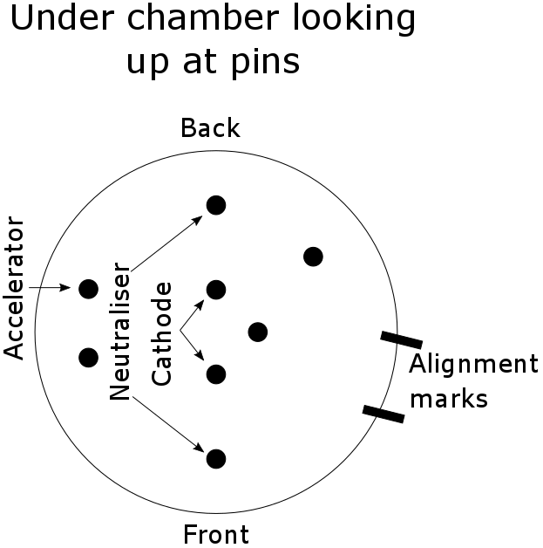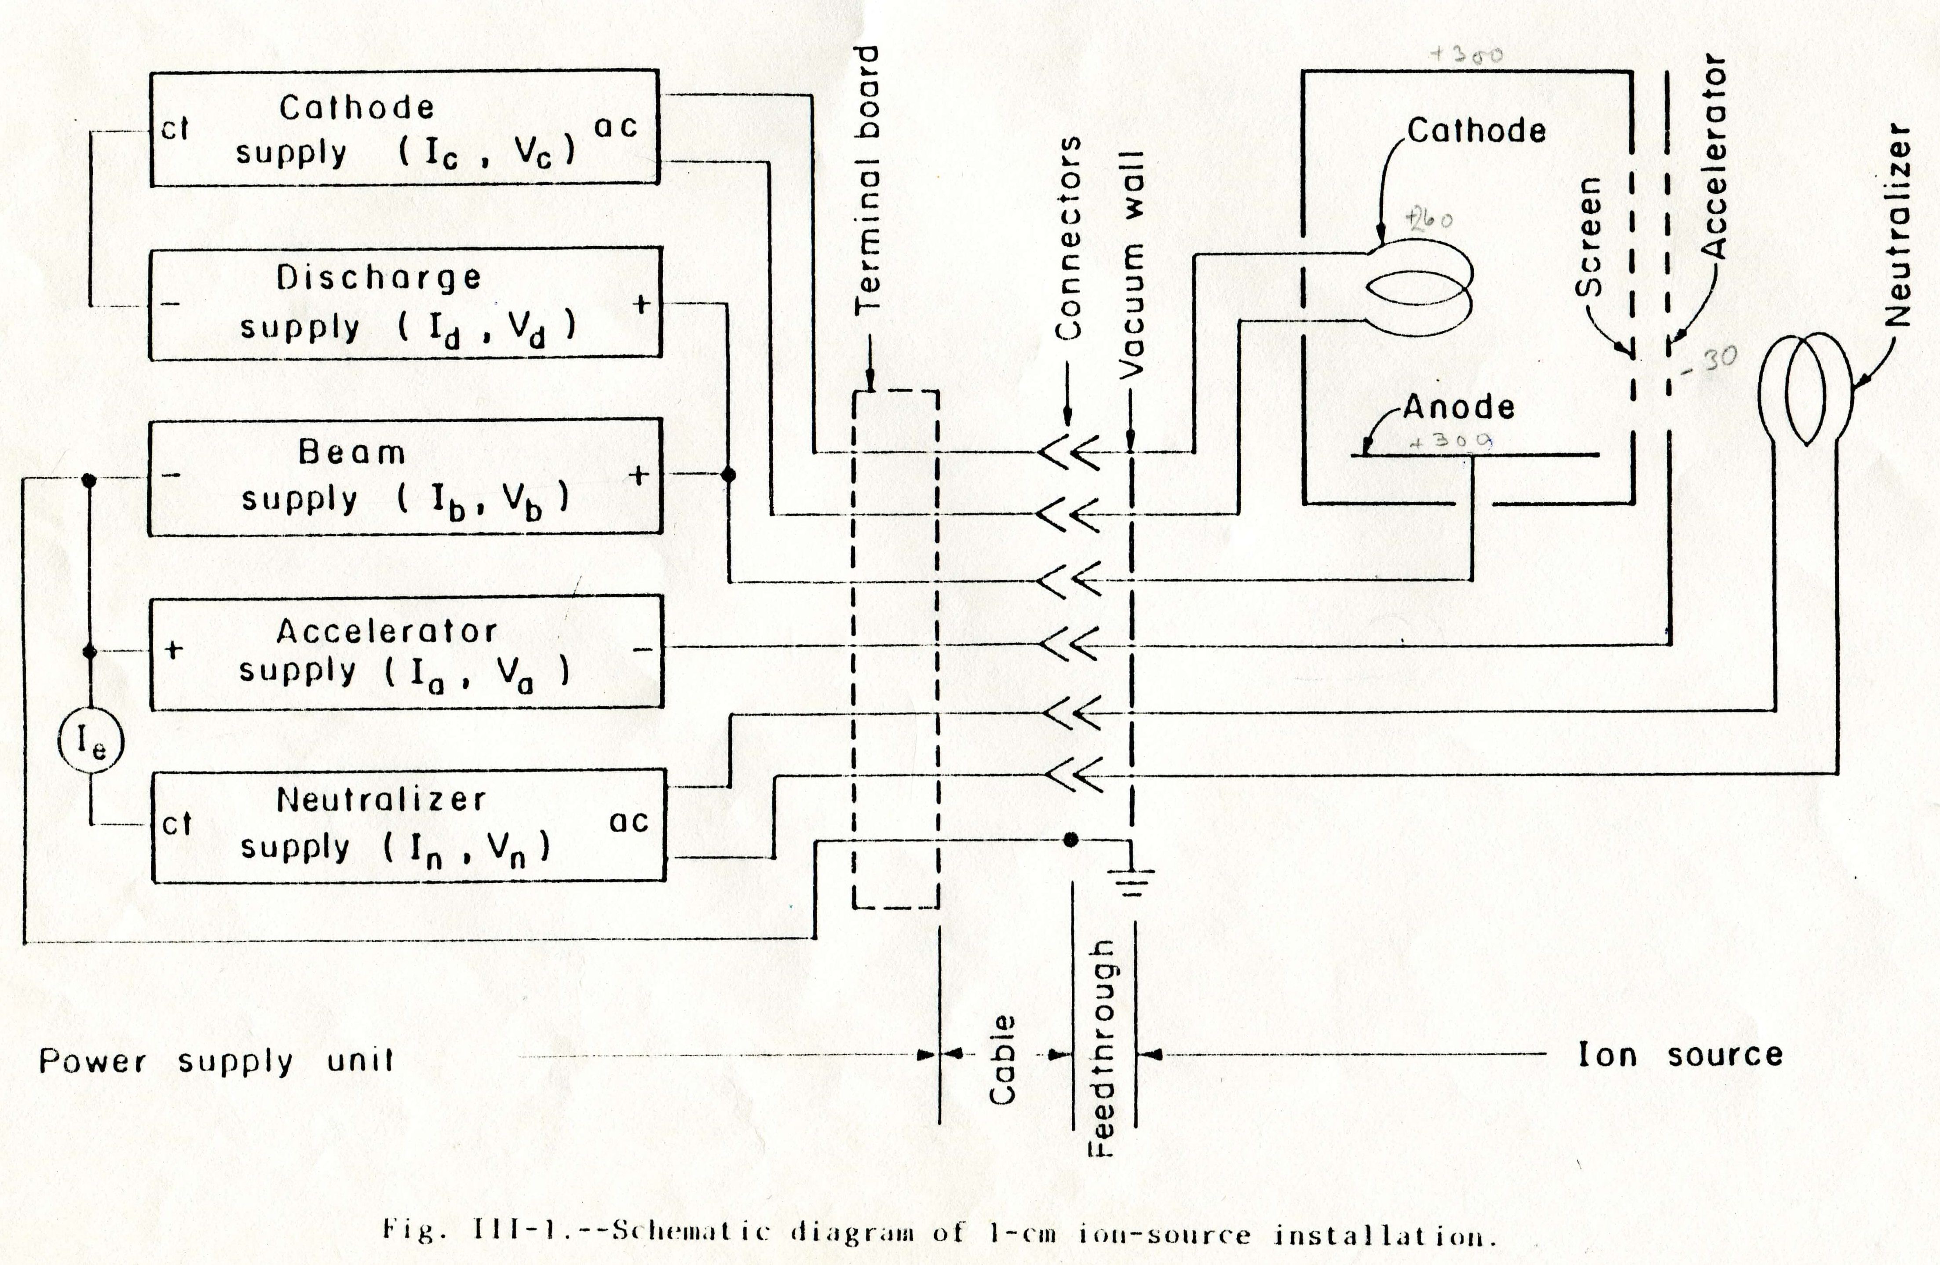
Opening/closing the chamber.
Turn off ion mill/SiO/Au if on and wait for them to cool (this might take a while).
Close gate valve, black Ar valve, gold roughing pump valve (if open), open the load lock to main chamber (if closed), turn off roughing pump, disconnect roughing pump hose. Now you are ready to vent the system with the green nitrogen valve. Open the chamber with the hook/lift mechanism. While the chamber is open you may wish to replace the aluminium on the shutter plate and scrape any flakes from the sample plate. Check the thickness of the Au target.
When closing the chamber; reattach roughing pump hose, turn the roughing pump back on and rough out the whole chamber using the gold valve. Wait until the chamber reaches the 10^-2’s, close the gold valve and flush with the dry nitrogen gas. Reopen the gold valve. This helps remove water vapor. Depending on humidity repeat 2x or 3x. When the roughing pump has done all it can, close the gold valve and slowly open the gate valve to the turbo pump. Check the green lights on the turbo pump control. If they are not all illuminated the pump is running slow or is over worked. Bake the chamber for ~8 hours (use the power regulator at approximately 50% otherwise the chamber gets too hot). If the chamber has been open for a long time the SiO may need to be outgassed before use.
Setting up power supply from scratch.
If the power supply has previously been used on another system, is in an unknown state, or is otherwise misbehaving it is a good idea to follow this procedure:
- Turn control knobs all the way down (counter clockwise).
- Power on supply. Leave for 15 minutes to warm up.
- Turn on “Source Beam” – left switch (5), check to see if any lights flash. At this point the discharge light might blink, but this is ok.
- Slowly increase the discharge to 39 V (pressing down on the black switch to view voltage).
- Slowly increase the cathode to ~4 A (may be higher for new filament). Now the discharge light should have stopped blinking (if it was to begin with). If not, try power cycling the supply.
- Switch on the second “Source Beam” (6). Make sure no lights are flashing.
- Increase accelerator voltage to 30 V.
- Increase beam voltage to 300 V and beam current 9.0 mA
- Increase neutralizer to 9.5 mA
- Values should now read:
Variable | Left Display (BEAM) | Right Display (MONITOR)
No switch pressed | Beam current (mA)  9.0 (controlled with cathode) | Accelerator current (mA)  0
Discharge |  | Discharge voltage (V)  39
Cathode |  | Cathode current (A)  3.6 – 4.2 (new filaments up to 5.5)
Beam Voltage | Beam voltage (V)  300
Accelerator |  | Accelerator voltage (V)  30
Neutraliser |  | Neutraliser current (mA)  9.5 (0.5 higher than beam current)
Replacing filaments (cathode or neutraliser lights blink).
If the cathode or neutralizer lights blink on the supply it is possible the filaments need to be replaced. The filaments can be checked using a DMM and the connector pins under the chamber. If the DMM reads low resistance (0-5 Ohms) the filament is ok, but if the DMM reads open circuit the filament is broken.
- Confirm with DMM that the filament needs to be replaced.
- Open the chamber following procedure above. Remove shutter plate.
- Carefully unscrew and remove the ion mill housing (picture 1). The neutraliser is the filament on the top of the housing. Do not touch the grid it is made from graphite and is very delicate and expensive to replace.
- The cathode can now also be removed by lifting it up with the Teflon plate (pictures 2 and 3).
- The filaments can be replaced using the green marked spool of wire. See pictures 1, 4, 5 and the schematic below for the ideal filament shape. Do not create sharp kinks or bends in the wire as these will become weak points when hot and shorten the lift of the filament.

- The cathode filament can be cut to length and shaped using the three posts (picture 5).
- Reassemble (picture 6, 7) and check with the DMM.
- You are now good to go. Close the chamber with the procedure above.
Accelerator light blinking (accelerator voltage 0 V).
The most likely cause of this is redeposition of milled material (chamber wall and shutter plate) onto the ion miller creating flakes and an electrical short between the accelerator and screen (see Manual III-5).
- Confirm the accelerator shows 0 V and a finite current when on.
- Unplug the power supply and white Teflon plug. Check with DMM the resistance between the accelerator plug and the ground (anywhere on the chamber). This should be an open circuit. If it is not we need to open the chamber and try to dislodge the short.
- Open the chamber following procedure above. Remove shutter plate.
- Carefully unscrew and remove the ion mill housing (picture 1)
- The electrical short is between the grid and the housing. Do not touch the grid it is made from graphite and is very delicate and expensive to replace.
- The flake may be invisible to the eye. Hopefully it can be dislodged by blowing nitrogen gas.
- Reassemble and check again for the short circuit. Rinse and repeat if short circuit still shows.
- If the short cannot be dislodged by blowing gas it might be necessary to take apart the ion mill housing. This is beyond the scope of this guide so consult the manual.
Refilling the SiO boat.
Helpful photos for the procedure described below, can be found in:
S:\Birge-Group\Technical_Info\LabNotes&Operation\IonMilling\Ion Source Photos\SiO Evaporation Source
- Open the chamber following procedure above. Remove shutter plate and collimator for SiO source. You may wish to clean the collimator while it is out.
- Disconnect screws to the copper current bars and remove the water lines connected to them (pictures 1, 2).
- Loosen and remove the screws (using two wrenches) and keep nuts and bolts paired together.
- Pull SiO boat out (picture 3 and 4).
- Vacuum the space where the SiO boat was from the side and the top.
- Loosen the screws holding SiO boat in place (picture 5).
- Remove the cap from the boat and refill boat with SiO pellets (located in the ion mill table draw) from the side of the boat labelled “FILL” (picture 6).
- Replace cap, remount boat in original orientation (open side facing centre of chamber) and tighten screws. Ensure there is no short between the boat and holder.
- Get a new copper gasket (should be the same size as old one).
- Put the SiO source back into the chamber and check that the SiO boat is aligned correctly (facing directly up, picture 7). Tighten screws and replace the water connection.
- Close and pump the chamber as above.
- Once the chamber reaches a good vacuum it is important to outgas the new SiO.
- Begin to slowly increase the voltage using the large black dial near the bottom of the electronics boxes. Make sure to go in steps of roughly 0.001 on the voltmeter each minute.
- Increase to 0.026, wait for one minute, and then bring it back down to 0.025. Wait for a few minutes here to allow the SiO to outgas (the pressure during this process may reach the 10^-6’s).
- Slowly cool the SiO by turning down the power in steps of 0.001 each minute.
- Let the system pump out again before inserting samples.

